**Table of Content**

|  |  |  |  |
| --- | --- | --- | --- |
| **S. no** | **Particular** | | **Page no.** |
| 1 | Introduction | | 2 |
| 2 | Background | | 2 |
| 3 | Data Analysis Process | | 3 |
|  | 3.1 | Ask | 3 |
|  | 3.2 | Prepare | 3 |
|  | 3.3 | Process | 5 |
|  | 3.4 | Analyze and Share | 5 |
|  | 3.5 | Act | 12 |

**Introduction**

In this case study, I will perform many real-world tasks of a junior data analyst at a fictional garment retailer, Vrinda Store. In order to answer the key business questions, I will follow the steps of the data process: Ask, Prepare, Process, Analyse, Share, and Act.

**Background**

**Vrinda Store:**

* Vrinda Store is a garment retailer company. Vrinda Store sells its product on different online platforms including Ajio, Amazon, Flipkart, Meesho, Myntra and Nalli.
* Vrinda store wants to create an annual sales report for 2022. So that, Vrinda Store can understand their customers and grow more sales in 2023.

**Scenario:**

I am assuming to be a junior data analyst working in the marketing analyst team at Vrinda Store, a Garment retailer. The director of marketing believes the company’s future success depends on their customers and grow more sales in 2023. Therefore, my team wants to understand how different variables affected sales and growth of company in 2022.

From these insights, my team will design a new marketing strategy to grow more sales in 2023. But first, Vrinda Store executives must approve our recommendations, so they must be backed up with compelling data insights and professional data visualizations.

**Data Analysis Process**

**Ask**

**Business Task**

Vrinda store wants to create an annual sales report for 2022. So that, Vrinda can understand their customers and grow more sales in 2023.

**Analysis Questions and Queries.**

1. Compare the sales and orders using single chart
2. Which month got the highest sales and order?
3. Which month got the lowest sales and order?
4. Who purchased more, men or women in 2022?
5. What are different order status in 2022?
6. List top 5 states contributing to the sales?
7. Relation between age and gender based on number of orders
8. Which channel is contributing to maximum sales?

**Prepare**

**Data source**

I will use Vrinda Store sales data to analyze and identify trends from Jan 2022 to Dec 2022 which can be downloaded from Github website.

This is public data that can be used to explore how different customer types buying different products of Vrinda Store from all over India.

**Data organization**

There is one excel file named ‘Vrinda Store Data Analysis (raw data).xlsx’ includes information for one year of sales data with column names such as index, Order ID, Cust ID, Gender, Age, Date, Status, Channel, SKU, Category, Size, Qty, currency, Amount. ship-city, ship-state, ship-postal-code, ship-country, B2B.

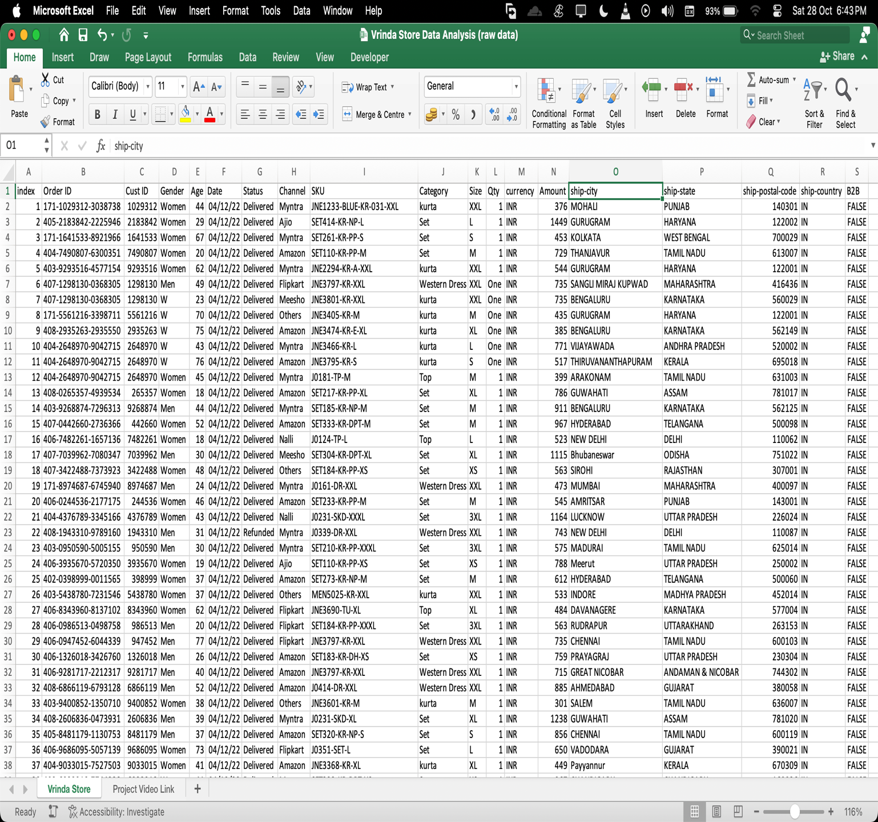

**Process**

**Data exploration**

Microsoft Excel is used for data exploration and to get familiarize with the data

**Data Cleaning**

Data cleaning and modification is done with the help of functions and formulas in Microsoft Excel

* Various Empty Rows were deleted and Rows that contained empty cell were either deleted or modified according to old data.
* Data types of some columns was changed for the purpose of data analysis.
* Some new columns were added with the help of old data.
* Some ambiguous data that would create hindrance while data analysis, was corrected.

**Analyse & Share**

After cleaning the data, it is ready for analysis. Microsoft excel is used for Data Analysis.

In data analysis we will find the answers to the Data Analysis Questions and Queries.

1. **Compare the sales and orders using single chart.**
2. **Which month got the highest sales and order?**
3. **Which month got the lowest sales and order?**

Pivot table of total sales and total numbers of orders in each month is prepared in Microsoft Excel with the Vrinda Store sales data.

|  |  |  |  |  |  |
| --- | --- | --- | --- | --- | --- |
| **Month** | | **Total Sales** | | **No. of Orders** | |
| Jan | | 1820601 | | 2702 | |
| Feb | | 1875932 | | 2750 | |
| **Mar** | | **1928066** | | **2819** | |
| Apr | | 1829263 | | 2685 | |
| May | | 1797822 | | 2617 | |
| Jun | | 1750966 | | 2597 | |
| Jul | | 1772300 | | 2579 | |
| Aug | | 1808505 | | 2617 | |
| Sep | | 1688871 | | 2490 | |
| Oct | | 1666662 | | 2424 | |
| **Nov** | | **1615356** | | **2383** | |
| Dec | | 1622033 | | 2384 | |
|  | |  | |  | |
|  | |  | |  | |

From pivot table Pivot histogram chart is and line chart is prepared to show the clear visualization of relationship between total numbers of orders and Total Sales.

From the above analysis it is clear that month of march recorded both highest numbers of orders and total sales and month of November recorded lowest numbers of orders and total sales.

1. **Who purchased more, men or women in 2022?**

Pivot table of total sale done by men and women is created.

|  |  |
| --- | --- |
| **Gender** | **Sum of Amount** |
| Men | 7613604 |
| Women | 13562773 |

With the help of pivot table of total sales by men and women a pivot pie chart is created in Microsoft Excel.

From above analysis it is evident that shopping done by women from Vrinda Store is more than shopping done by men.

1. **What is different order status in 2022?**

A pivot table is created in Microsoft Excel with the data of aggregate number of order ids and their order status.

|  |  |
| --- | --- |
| **Order Status** | **Count of Order ID** |
| Cancelled | 844 |
| Delivered | 28641 |
| Refunded | 517 |
| Returned | 1045 |

From the pivot table prepared from the data of order ids and their order status a pivot pie chart is prepared in Microsoft excel.

This analysis shows the total aggregate order status of the year. 92% orders are delivered.

1. **List top 5 states contributing to the sales?**

A pivot table is prepared from the sales data of every state and top 5 is selected.

|  |  |
| --- | --- |
| **State Name** | **Total Sales** |
| MAHARASHTRA | 2990221 |
| KARNATAKA | 2646358 |
| UTTAR PRADESH | 2104659 |
| TELANGANA | 1712439 |
| TAMIL NADU | 1678877 |

From the pivot table of top 5 state contributing to the sale a pivot histogram chart is prepared.

From above analysis it is found that Maharashtra, Karnataka, Uttar Pradesh, Telangana and Tamil Nadu are top five states with highest number of sales.

1. **Relation between age and gender based on number of orders**

A pivot table is created from gender, age group and number of orders, percentage of men and women in each age group is calculated in this pivot table.

|  |  |  |
| --- | --- | --- |
| **Age Group** | **Men** | **Women** |
| Adult | 15.47% | 34.59% |
| Senior | 5.91% | 13.70% |
| Teenager | 9.20% | 21.13% |

From this pivot table a pivot histogram chart is prepared to visualize the result of this analysis.

From the above analysis it is evident that adults are with the greatest number of orders and women has ordered most in each age group.

1. **Which channel is contributing to maximum sales?**

With sales data a pivot table is prepared of percentage share of sales of every channel.

|  |  |
| --- | --- |
| **Channel Name** | **Count of Order ID** |
| Amazon | 35.5% |
| Myntra | 23.4% |
| Flipkart | 21.6% |
| Ajio | 6.2% |
| Nalli | 4.8% |
| Meesho | 4.5% |
| Others | 4.1% |

With pivot table of percentage share in total sale of every channel a pivot pie chart is prepared.

From this analysis we can state that Amazon has the largest share of sales among each channel.

**Summary of analysis**

* Month of march recorded both highest numbers of orders and total sales, and in November least number of orders and sales is recorded.
* From above analysis it is evident that shopping done by women from Vrinda Store is more than shopping done by men.
* 92% orders are delivered.
* Maharashtra, Karnataka, Uttar Pradesh, Telangana and Tamil Nadu are top five states with highest number of sales.
* adults are with the greatest number of orders and women has ordered most in each age group.
* Amazon has the largest share of sales among each channel, and Ajio, Nalli and Meesho has the smallest share in sales.

**Act**

After thorough review of analysis of sales data of 2022 following points have been concluded

* Vrinda Store should maintain its customer demand in the highest sales month as well as create new demand for products in months with lowest number of sales.
* Store should focus more on men clothing as well as maintain its women customer base.
* Store should include more collection for elderly and teenagers and include more verities for its adult customer base to maintain current as well as create new demand.
* Vrinda Store is selling very little to no quantity on other than Amazon, Flipkart and Myntra, more analysis is needed in that particular area to find the reason behind this.